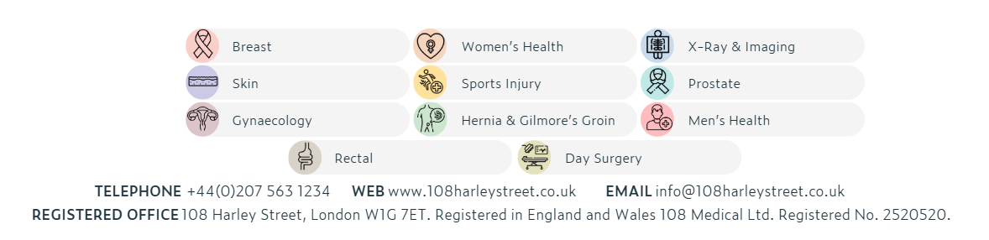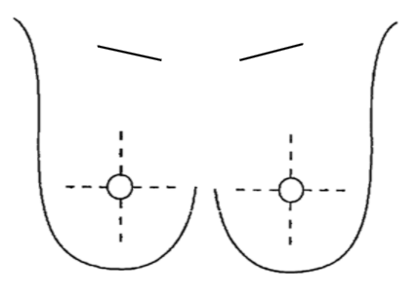

**History**

Previous Breast Surgery

__________________________________________

Breast Implants Yes No

Date of Last Mammogram: ____________________

Location of Last Mammogram: _________________

__________________________________________

Family History of Cancer:

__________________________________________

Any anticoagulant? Yes No

**Does the patient need to stop it for 48 hours prior to exams?**

Yes No

Clinical Indication:

Annotate site of symptoms or exam findings

**Patient Details**

Forename: __________________________

Surname: ___________________________

Previous surname: ____________________

Date of Birth: ________________________

**Referring Doctor**

Name: ____________________________________

Address: __________________________________

_________________________________________

Tel: ______________________________________

Signature: _________________________________

Date: _____________________________________

Justified By: ________________________________

Date: _____________________________________

**Examination Required**

R L Both

Mammogram

US Breast

US Axilla

Other: ____________________________________

X-Ray & Imaging

**breast radiology REQUEST FORM**

Please ensure previous mammograms available for appointment